**Device Characteristics**

**Does the GaN enhancement mode HEMT have a body diode? How do the reverse conduction characteristics compare with a silicon MOSFET?**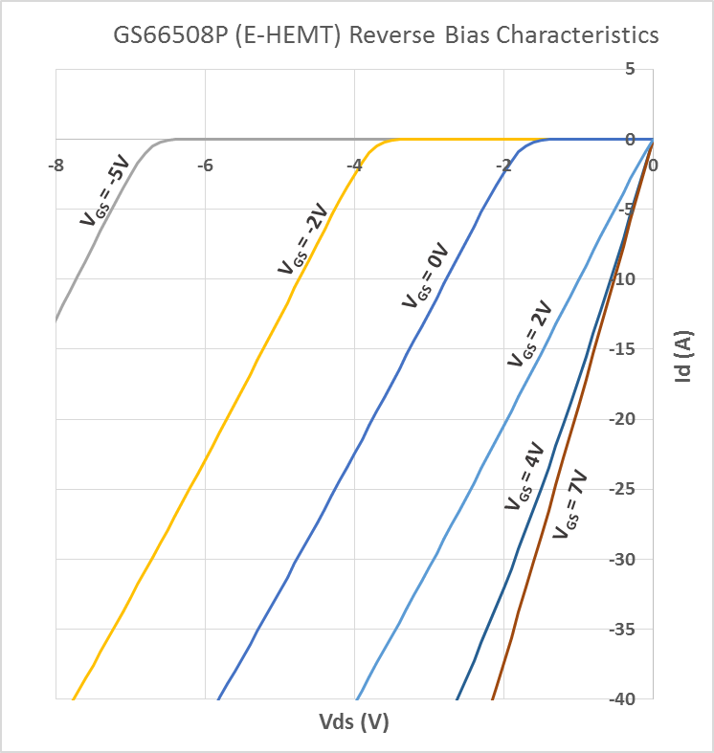

GaN Systems enhancement mode HEMTs do not have an intrinsic body diode and there is zero reverse recovery charge. The devices are naturally capable of reverse conduction and exhibit different characteristics depending on the gate voltage. At the system level, the reverse conduction capability can be an advantage compared to IGBTs because no anti-parallel diodes are required.  
  
On-state (VGS = +6 V):  
  
The reverse conduction characteristics of a GaN Systems enhancement mode HEMT in the on-state is similar to that of a silicon MOSFET, with the IV curve symmetrical about the origin and it exhibits a channel resistance RDS(ON)similar to forward conduction.  
  
Off-state (VGS ≤ 0 V):  
  
The reverse characteristics in the off-sate are different from silicon MOSFET as the GaN device has no body diode. In the reverse direction, the device starts to conduct when the gate voltage in respect to the drain (VGD) exceeds the gate threshold voltage and then the device exhibits a channel resistance. It can be modeled as a “body diode” with slightly higher VF and no reverse recovery charge.  
  
If negative gate voltage is used in the off-state, the source-drain voltage must be higher than Vth+VGS (OFF) in order to turn the device on. Therefore, a negative gate voltage will add to the reverse voltage drop “VF” and hence increase the reverse conduction loss.

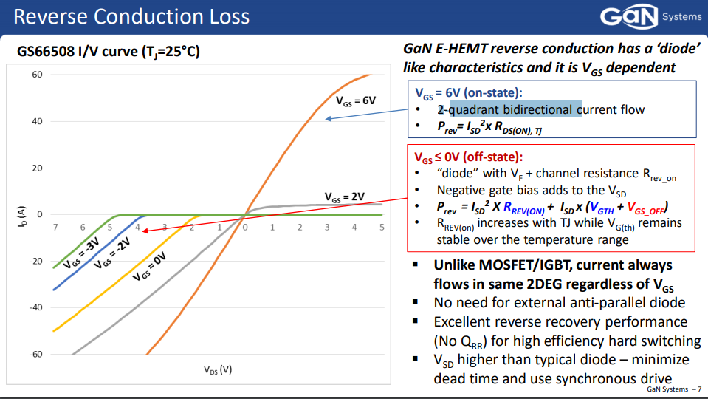

Figure 1. GaN Dokümanında bulduğum loss hesapları, Rrev_onu grafikten çektim

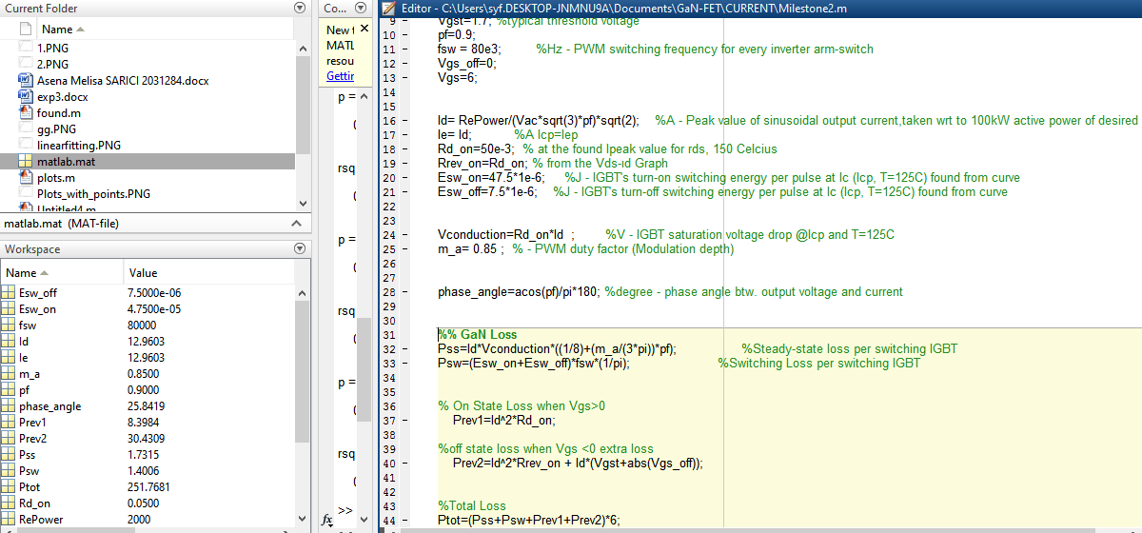

Figure 2. Burda hesapları bulduğum kod var, en son totali bulmak adına 6 ile çarpıyorum

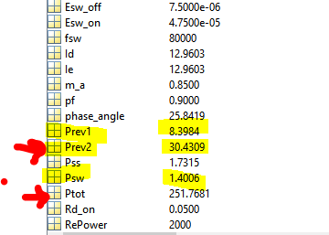

Figure 3. Psw nin On state reverse loss tan az olması normal mi? Yoksa Prev1 zaten onu kapsıyor mu? (Prev1 için lütfen Figure 1e gidin)

